|  |
| --- |
| **A Report on**  Stiften Donation App  Submitted for partial fulfillment of award of  **BACHELOR OF TECHNOLOGY**  degree  In  Computer Engineering & Information Technology  By  Aman Sharma (1803211007)  Aanchal Giri (1803211001)  Supervisor Name  Mr. Ashwin Perti    **ABES ENGINEERING COLLEGE, GHAZIABAD**  **Dr. A P J ABDUL KALAM TECHNICAL UNIVERSITY, LUCKNOW**  **April 2022** |

**Certificate**

Certified that **Aman Sharma** has carried out the project work presented in this report entitled **“Stiften Donation Application”** for the award of **Bachelor of Technology** from ABES Engineering College, Ghaziabad, under my supervision. The report embodies result of original work and studies carried out by Student himself/herself and the contents of the report do not form the basis for the award of any other degree to the candidate or to anybody else.

(Mr. Ashwin Perti)

Designation: Assistant Professor

Address: CS Deptt, ABES Engineering College

Date:

**Acknowledgement**

\

We take this opportunity to thank our teachers and friends who helped us throughout the project.

First and foremost, I would like to thank my guide for the project ( **Mr. Ashwin Perti, Assistant Professor, CS Department**) for her/his valuable advice and time during development of project.

We would also like to thank **Dr. Pankaj Kumar Sharma (HOD, Computer Science Department**) for his constant support during the development of the project.

Name- Aman Sharma Name- Aanchal Giri

Roll No.-1803211007 Roll No.- 1803211007

Signature Signature

Declaration

*I hereby declare that this submission is my own work and that, to the best of my knowledge and belief, it contains no material previously published or written by another person nor material which to a substantial extent has been accepted for the award of any other degree or diploma of the university or other institute of higher learning, except where due acknowledgment has been made in the text.*

*Signature:*

*Name: Aman Sharma*

*Roll No.:*

*Date:*

**Abstract**

*The purpose of the project entitled “****STIFTEN DONATION APPLICATION****” is to automate the Donation System for organizations (NGOs) and the financial aid help seekers. The software which will be user friendly, simple, fast, and cost effective. It is a donation dapp (decentralized) that can accept payment done through both medium that is crypto-currency and normal Indian currency via Razorpay payment gateway and in crypto currency both. It is made to ease the work for donors so now they won’t be needing to find the organization from different corners of the world. Instead they will have the list of organization from all the places nearby. It will help in gaining trust of customers (donors).*

**TABLE OF CONTENTS**

**CHAPTER NO. PAGE NO.**

**ABSTRACT iii**

**LIST OF TABLES xvi**

**LIST OF FIGURES xviii**

**LIST OF SYMBOLS, ABBREVIATIONS xxviii**

**1. INTRODUCTION Page No**

|  |
| --- |
| 1.1 Problem Definition  1.2 Introduction about your project. Objective(s) of the project.  1.3 Project Overview/Specifications  1.3.1.Functional Requirements  a) External Interface requirements  User interface Requirements  H/w Interface Requirements          S/w interface requirements          Communication Interface  b) Memory Constraints    **2. LITERATURE REVIEW**  **3. SOFTWARE REQUIREMENT ANALYSIS**  3. 1 Modules and their functionalities  3.2 Use Case diagrams |

**4. SYSTEM ANALYSIS & DESIGN**

4.1 Class designs (Wherever applicable)

4.2 Sequence diagrams

4.3 Activity Diagrams

4.4 DFDs of the project

4.5 Database Design

4.5.1 E-R Diagrams

**5.**  **CODING /CORE MODULE**

5.1 Tables – explaining all fields and their data types for data base used in project.

5.2 Used Algorithms/Approaches for Research projects.

5.3 Major / important functions of the projects.

|  |  |
| --- | --- |
| **6. RESULTS / OUTPUTS & TESTING**  6.1 All user interfaces and output screens  6.2 Layouts of web Pages and screens  6.3 Design and Test Steps / Criteria  6.4 Testing Process | |
| **7. CONCLUSIONS / RECOMMENDATIOS** |
| **8. REFERENCES** |
| **9. APPENDICES**  9.1 Details of software/simulator if any  9.2 Steps to execute/run/implement the project  9.3 Coding if any |

**Chapter 1**

**INTRODUCTION**

### **Problem Definition**

### In today’s world there are various barriers between a donor and the receiver. The donors these days tend to avoid donating through the various online available platforms because of the scams which have taken place in the recent times. The donors have a fear of losing their hard earned money to the scammers even though the donors have a good intention at their heart. The donors from all over the world do not always want to donate to the citizens of their own respective countries, instead they desire to send their affection to the citizens of the other countries, but there is no feasible medium of currency decentralization which leads to them not being able to donate the funds to the people who really need it and also to the contradiction of the basic idea of globalization.

### The problems are rooted in the facts that the donors can not always perform a background check on the medium they are using for the donation and also none of the present donation mediums connect the globe as one.

### **1.2 Introduction about your project. Objective(s) of the project**

### The donation decentralized app is based on react and solidity. It will help in gaining trust of users (donors). It will be supporting donations in both Indian currency via Razor pay payment gateway and in crypto currency both. In today’s world nothing can be trusted blindly and the good donors don’t have enough time to do the background check for all the organizations so this application will do all the work for them already. We will have a personal curated list for those donors so that they don’t have to invest their precious time in checking the background for the organization, if it is fake or real. In any case they know how is the organization, they can rate and comment about that organization. The list will be shown to him according to their location. The organizations details will be provided along with list. The details will have the organization name, address and the nearest site where they provide the services so that if you want then you can go there and watch things for yourself. It will also be containing a slideshow of the images. Once a customer gets himself verified on the app. He will be allowed to become the active volunteer for the organization. He will be provided with the contact within the app so that he can talk to them and ask them where is the nearest site for him to help. If there is no site near to his place or not in his city, and there is a place where help is needed he can apply for the new site for that city and he will be needed to wait to get verified. Verification will be done on the basis of number the applications for the particular site.

### **Project objective**

The main objective is to ease the problems regarding security and assurance of the donor’s money while donating to several organizations. The organizations details will be provided along with list. The details will have the organization name, address and the nearest site where they provide the services so that if you want then you can go there and watch things for yourself. Along with all the information it will be having the GST or ISO will be verified.

Second most important objective of Stiften is to ensure the organization that they have received all the money they were expecting from the donor.

# Chapter 2

# LITERATURE REVIEW

## Currently the NGO organizations are accepting donations or payments through different or various channels or mediums.

## So the main problem for NGOs is that they don’t have a medium through which they can accept donations for the donors and they can’t keep track of all the donations made by different donors.

## There is also a big problem for donors to understand and do the background check of each organisation that it is fraud or real.

## If a donor want to volunteer for the social work he doesn’t know where to get the information for that.

## Integrity: -

## Stiften solves all the problem regarding the organization integrity, you can check where does the organization uses your money

## Confidentiality: -

Stiften solves your currency barriers, now you can pay in both Indian currency and crypto currency

## Crypto Currency Barrier: -

Stiften solves your currency barriers, now you can pay in both Indian currency and crypto currency.

# Chapter 3

# SOFTWARE RECQUIREMENT ANALYSIS

# SCOPE

The project would allow users to donate to the favorite organizations with ease in both crypto currency and Indian currency through razorpay gateway. This will help users to make their donations more precise and worthy that will satisfy them. Solidity is used in this application.

# 3.1 Modules and their functionalities

The entire project mainly consists of 4 modules, which are:

* Admin Module
* User Module
* Organization Module

## 3.1.1 Admin Module:

* Different portals for customers, organizations, and admin.
* Authentication will be implemented.
* Admins can add new organizations and accept the application of organisations and NGOs.
* Admins will verify user and can deactivte account of user due to inactivity.
* Admins can monitor all the transactions and provide the receipt.

## 3.1.2 User Module

* Customers will be a number of organizations and NGOs

## Each organization will have a details page.

## The organisation list will have the two filters one for nearest to customer location and the second will be through ratings.

## Customers can rate the NGO or organisation

## Customer can pay in Indian currency as well as cryptocurrency.

## Customers can participate in the ngo activities that are near them through participation tab.

## 3.1.3 Organisation Module:

* New Organisations can apply to this app.
* They can update their information about them.
* They can add new activities that will be performed by them.

New volunteer can be accepted by them and that volunteer's contact will be shared to them.

# 3.2 Use Case Diagram

# 

# Figure 1. Use Case Diagram

**Chapter 4**

**SYSTEM ANALYSIS & DESIGN**

**4.1 Class designs**

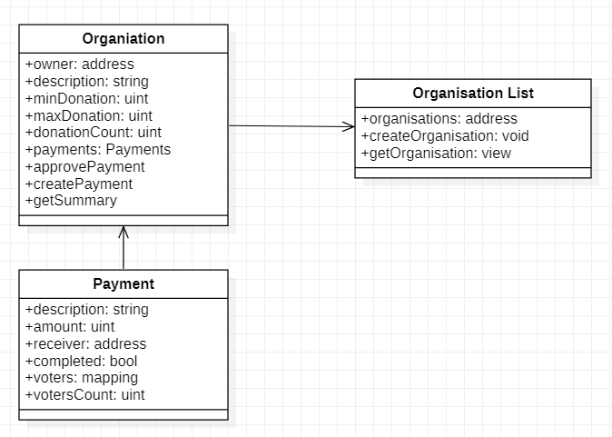

Figure 2. Class Diagram

**4.2 Sequence diagrams**

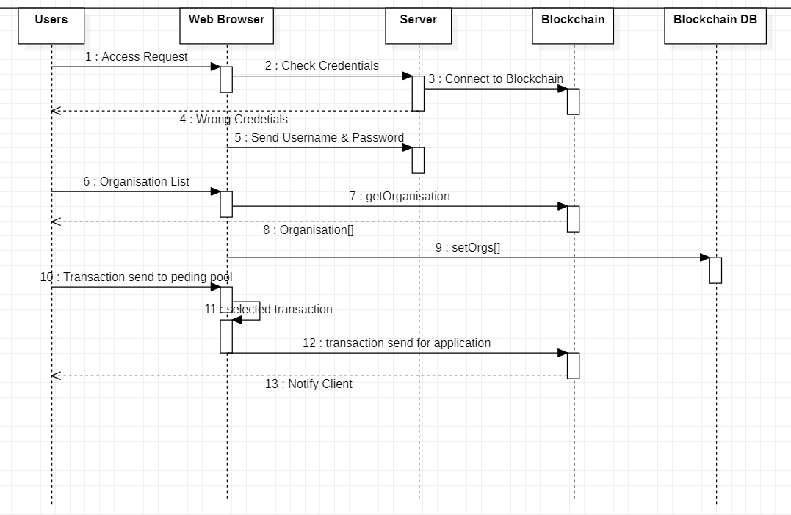

Figure 3. Sequence Diagram

**4.3 Activity Diagrams**

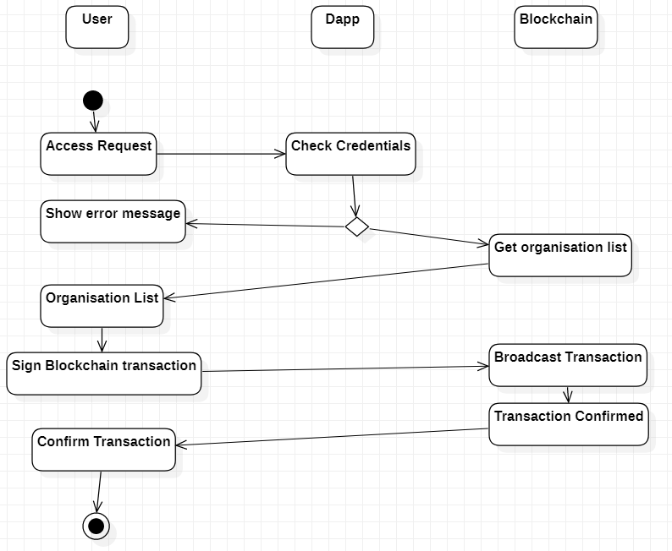

Figure 4. Activity Diagram

**4.4 DFDs of the project**

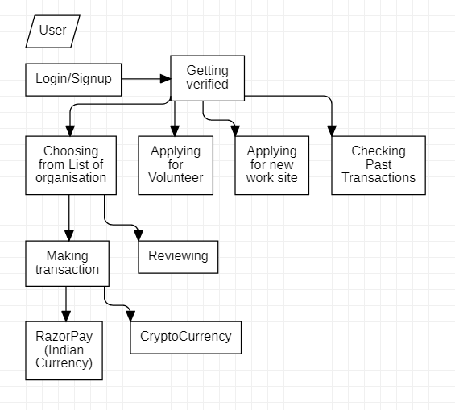

Figure 3. Data Flow Diagram

**Chapter 6**

**Implementation And Result**

**Conclusion**

Taking into account all the mentioned details, we can make the conclusion that the Stiften Donation Application is the inevitable part of the lifecycle of the modern donation institution. It automates numerous daily operations and enables smooth interactions of the users. Developing the donation system software is a great opportunity to create the distinct, efficient and fast delivering education model. Implementation of Stiften Donation Application project helps to store all the kinds of records, provide coordination and user communication, implement policies, improve day-to-day operations, arrange the supply chain, manage financial and human resources, and market hospital services. This beneficial decision covers the needs of the users, staff and simplifies their interactions. It has become the usual approach to manage the hospital. Many college and school have already experienced its advantages and continue developing new Stiften Donation Application project modules.

# References

* + - https://docs.soliditylang.org/en/v0.8.10/
    - https://reactjs.org/docs/getting-started.html
    - https://nextjs.org/docs/getting-started
    - https://docs.mongodb.com/
    - https://nodejs.org/en/docs/
    - https://devdocs.io/express/